**Docker port**

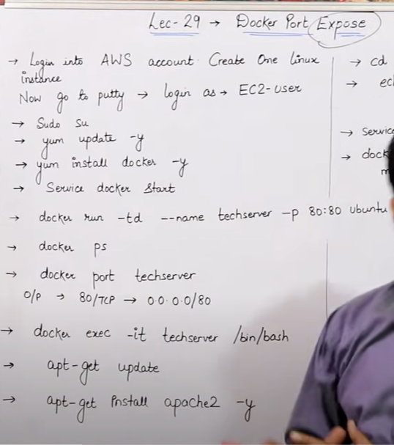

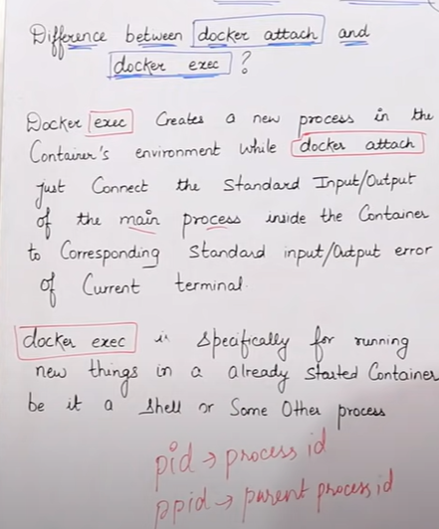

* Docker exec ka matlab hai expose karna, agar mein koi purana kaam apane terminal par kar rah ahu aur mujhe urgently kisi new kaam ko karne kein liye naya terminal chahihe oh uske liye hum exec command use karte hai
* Docker exec ka matlab hai ki agar mera koi container ka terminal chal raha aur hum chahate hai ki eak usi container ka naya terminal khul jaye toh vaha hum exec command use karte hai .

**expose** = (**expose matlab exec)** Agar mene expose command chalayi toh humara port open toh ho jayega but publically kisi ko nahi pata cahelega mera matlab host machine kein andar jitane bhi container hai vo aapas mein communicate kar sakte hai but agar koi banda internet kein madyam sein aaye aur humare container data dekhana chahe toh vo dekh nahi sakta.

**Public =** (public means -p) public command hum tab use karte hai jab hum ye chahate hai humare container ka data koi bhi dekh sake vo publically accessible ko koi bhi internet user dekh sakta ho tab hum use karte hai public

* Agar mene na **expose** chalaya na hi mene **public** chalaya toh uske liye mujhe data dekhane kein liye har eak container kein adar jaake tab uska data dekhana padega vo host machine kein andar jo bhi container honge unse bhi vo communicate nahi kar paa raha hoga .s

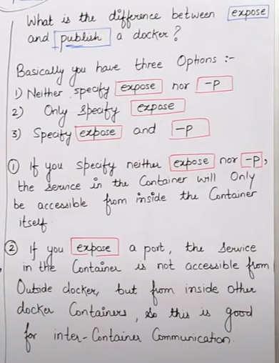

* Agar mene container mein expose aur public dono command use kar liya toh uske liya toh hum docker kein bahar yani kahi sein bhi hum container kein data ko access kar sakte hai kyu ki uske port khul gaye hai ab .

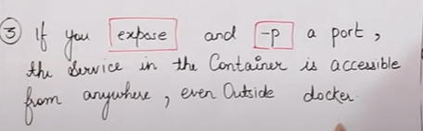

* Agar mene **expose** nahi kiya kewal **public** command use kiya toh humare sab port khul jayenge koi kahi sein bhi humare container ka data access kar sakta hai humein jaruri nahi tab ki hum expose command chalaye. Humare host machine kein jitane container hai vo bhi aaaps mein communicate kar payenge jaruri nahi phir ki expose chalaye .

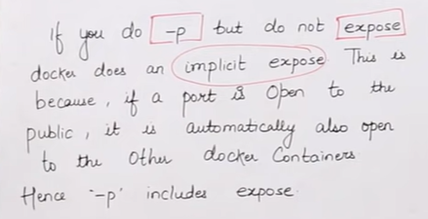

**docker run –td --name Alahabad -p 80:80 ubuntu**

* Yaha mene td isliye likha hai container ko banaye or run kare but run karane kein baad mujhe container kein andar na le jaye container run ho jaye aur mein container kein bahar rahu, aap dekh sakte ho container bana gaya aur run bhi hogaya but mein container kein bahar hu .
* -- name Allahabad mene apane container ka name diya hai
* - p 80:80 -**p matlab port** iska matlab **host** kein port number 80 ko aap **container** kein port number 80 kein sath connect kar dijiye aur vahi connection ko hum maping kehate hai .
* Hum host machine mein koi bhi port define kar sakte hai ,but hum container kein andar by default 80 port hi rakahate hai usko change nahi karate .

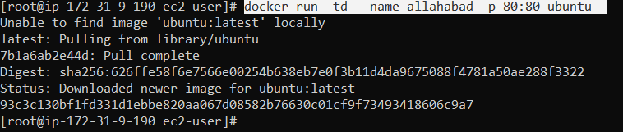

* Hum dekhenge humara port map ho gaya yaha aur humare host machine ka port number 80 bhi humare is container kein port number 80 sein map ho gaya hai .

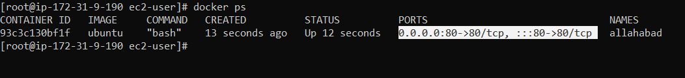

* Agar humko apana port number check karna ho toh is COMMAND sein kar sakte hai .

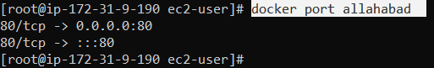

* **docker exec –it Allahabad / bin/bash**

ye command hum container kein andar ghusane kein liye use karte hai aur **exec** ka matlab hai ki ye eak naya process start kardeta hai neeche hum isko aur achee sein padhenge .



* **apt-get update**

agar humko ubuntu machine par motlab Ubuntu container ko update karna hai toh hum **apt-get update** command use karte hai .

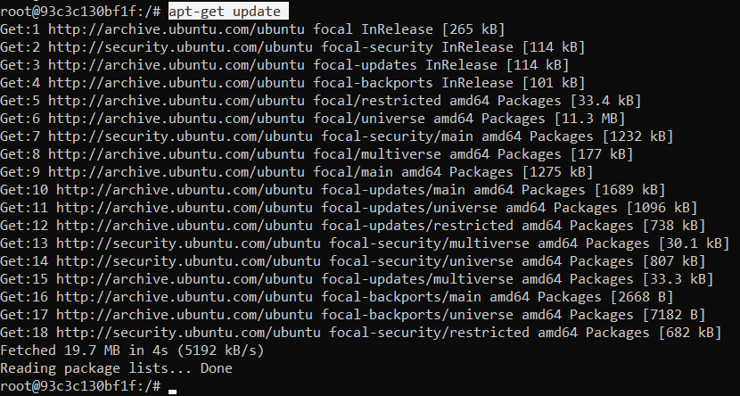

* **apt-get install apache2 -y**

mene apane ubuntu machine mein apache2 we server kein packages ko install kar diya jisase agar mujhe kisi webpage ko run karna ho toh hum kar sake aage dekhnege kaise webpage ko port sein connect kakre net par dalenge.

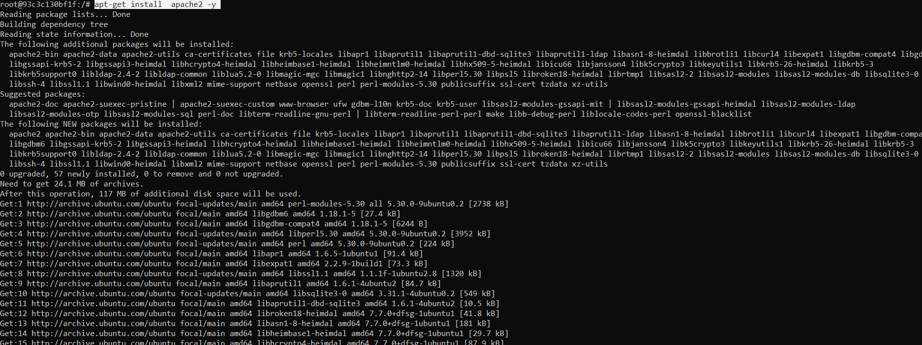



* **cd / var/www/html**

hum apne Ubuntu host machine kein root directory kein andar iss directory par jayenge aur yein by default bana hota hai , aur hum html directory kein andar jaake eak **index.html file** banayenge phir hum us html file kein andar kuch likhenege aur uso save kar denge .

* **echo “ hello satyam how are you”> index.html**

mene echo command isliye likha hai ki hum index.html file mein likhenege aur usko push kar denge hum index.html file kein andar.

* **Service apache2 start**

Yaha mene apne apache server2 jo install kiya thaa usko start kar diya hai

* Phir mene ejo index.html page banaya thaa usko agar humein apane browser par dekhana hai toh uske liye hum apane host machine ki ip apane browser par dalenge toh vo humko dikha dega .aur nahi toh hum apane ip kein last mein :80 laga denge kyu ki mera port vahi hai

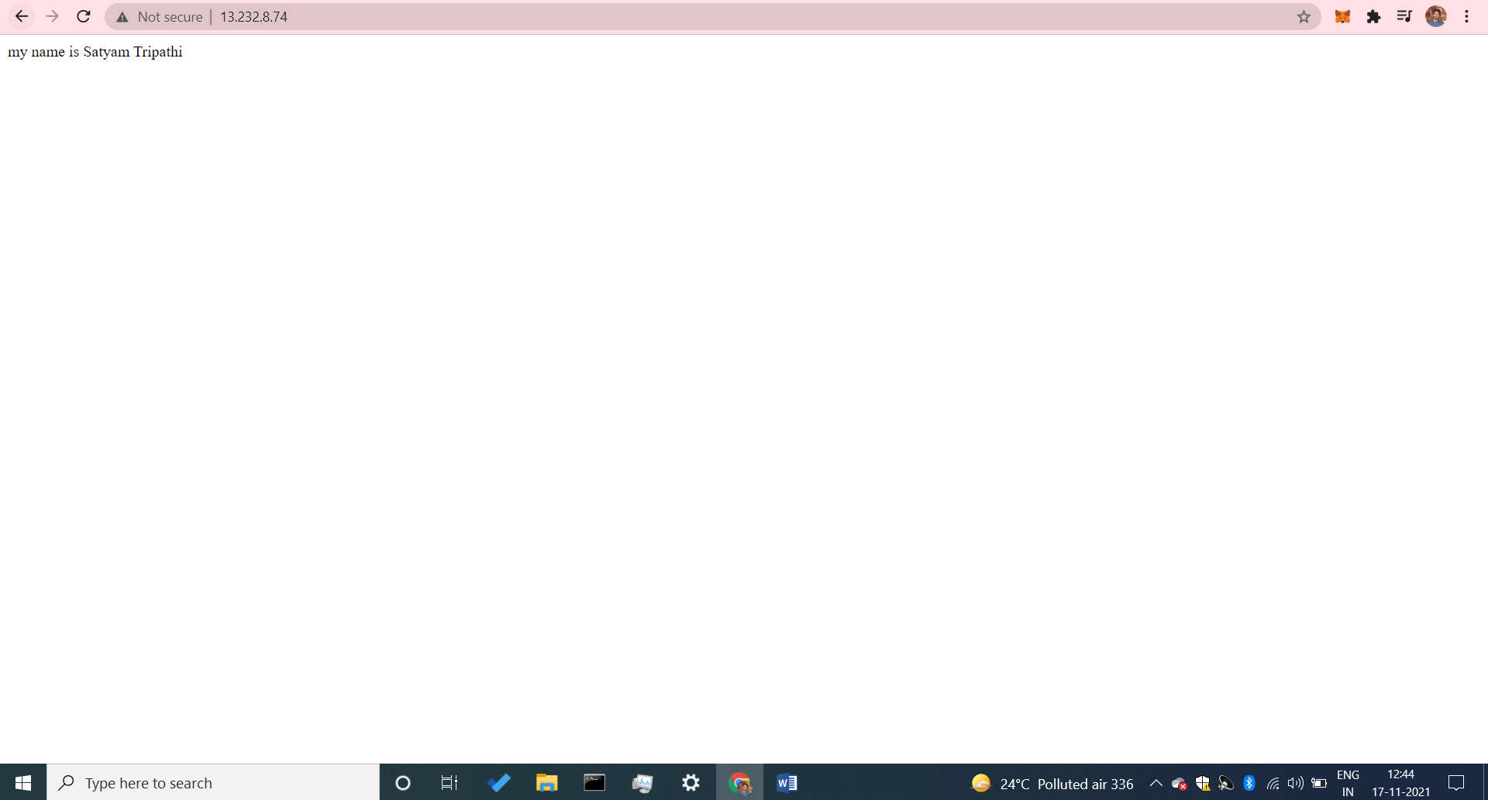

* **Our container**



* Mene phir eak Jenkins ka container banaya hai aur uske andar mene ports 8080 jenkins ko de diya hai matlab humare port par 8080 par jo bhi aayega usko Jenkins ki cheeje dikhyenge

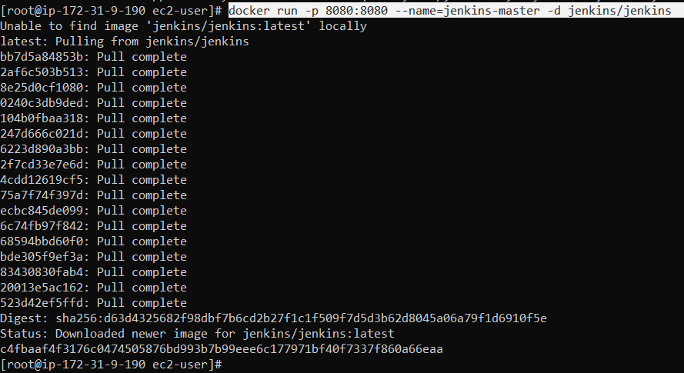



* Hum apane host machine mein jayenge aur inbound rule mein port 8080 ko allow kar denge jisase humara container ka port 8080 aur humare host machine ka port 8080 map ho jayega.

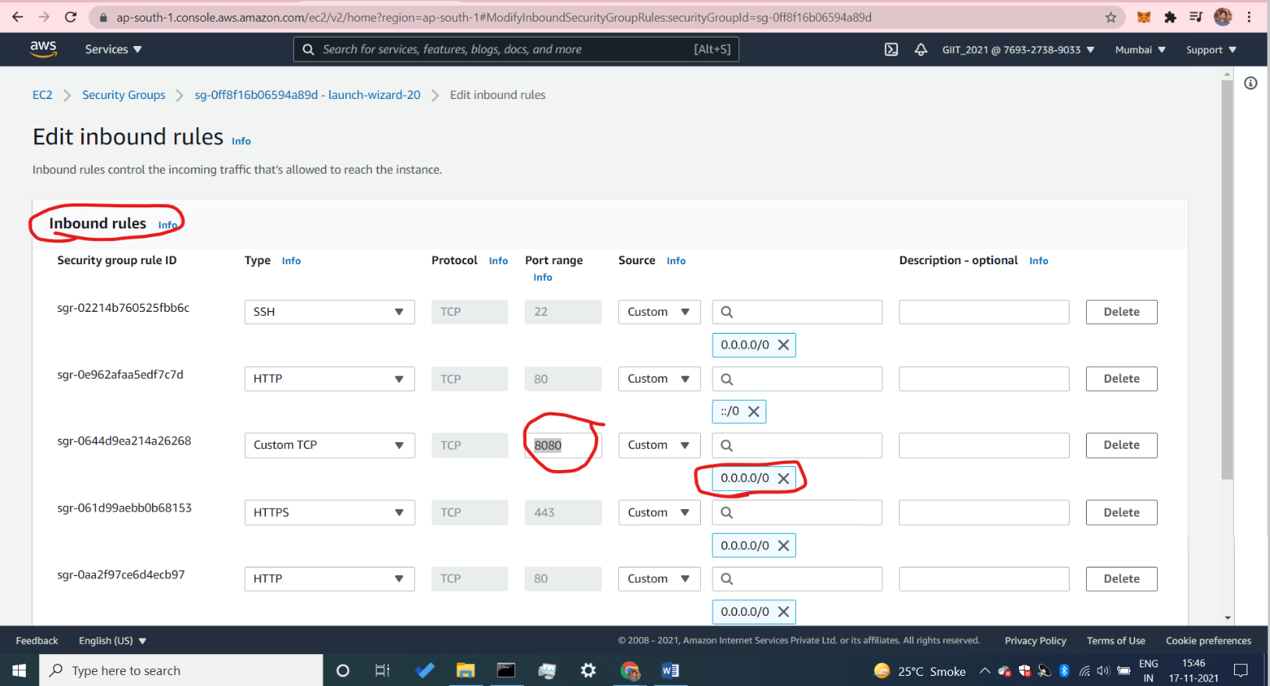

* Phir mein jab mein apane ip ko browser par dalunga aur last mein :8080 laga dunga toh vo mere Jenkins vale page par lete jayega
* **http://13.232.8.74:8080/**

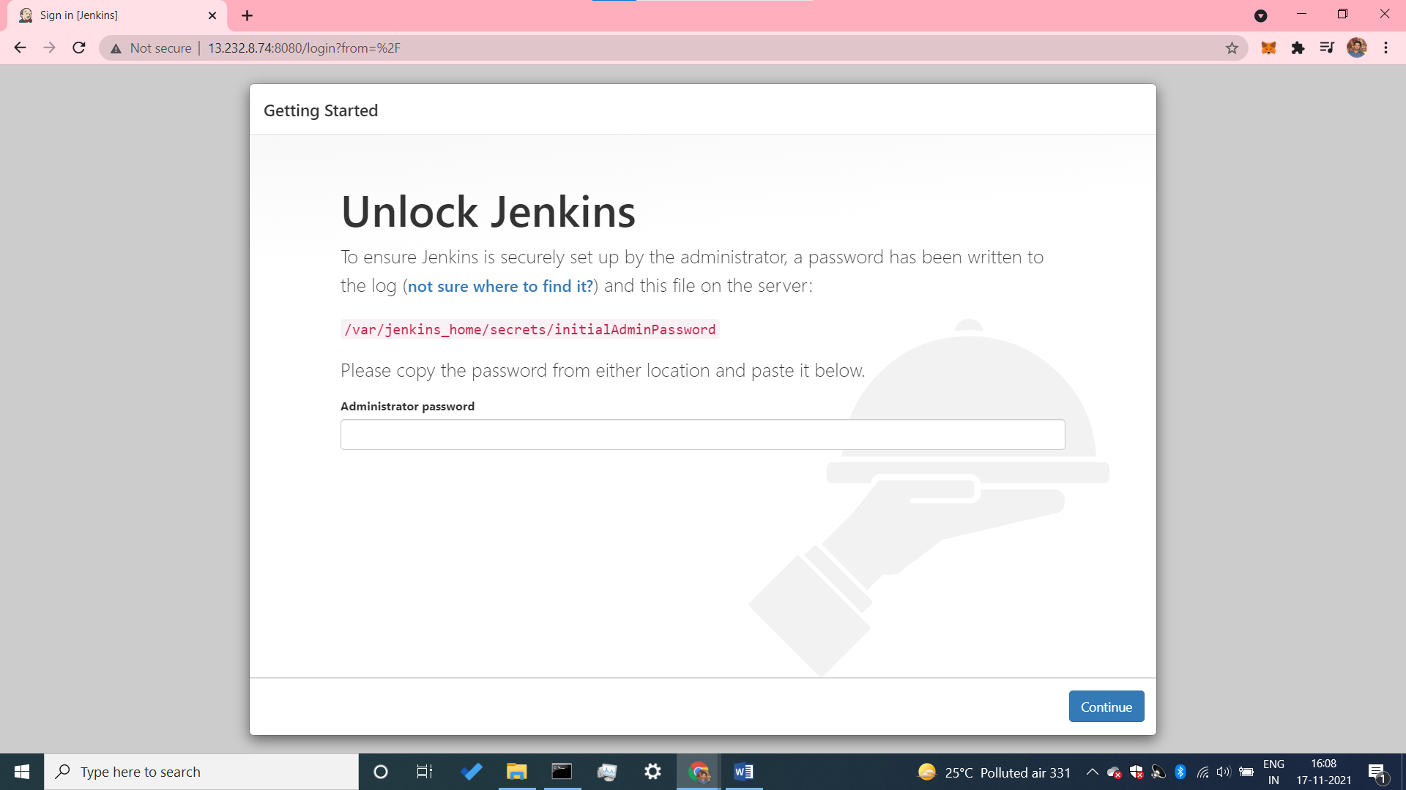

* agar hum container ko stop ya phir delete kar dete hai toh humare sab port unmap ho jate hai, phir host aur container kein beech mein koi vasta nahi rehata .